Temasek Polytechnic
School of Informatics and IT

Diploma in Information Technology (IT)

Software Design Specifications (DS)

Project Particulars

Tutor

Class | P01
Project Title | Delonix Regia Hotel Management System

Project Team’s Particulars

Matric Number | Student Name

Revision History

Date | Version | Description | Author
27/05/2016 | 1.0 | Compiled Final | Raymond

Table of Contents

1. DISTRIBUTION OF WORKLOAD 4
2. ARCHITECTURE DESIGN 4
3. USER INTERFACE (UI) DESIGN 5
4. PROGRAM DESIGN 9
5. DATABASE DESIGN 16

DISTRIBUTION OF WORKLOAD

Design | Members
Database Design, Program Design | Raymond
User Interface Design | Jia Chen
Architecture Design | Nadirah

ARCHITECTURE DESIGN

The proposed system architecture design for this system is the 2-tier architecture. A 2-tier architecture is a software architecture in which a presentation layer or interface runs on a client, and a data layer or data structure gets stored on a server.

Why 2-tier architecture?

Unlike the 3-tier architecture which is a web-based application, the 2-tier architecture is more based on the client and server; it is like a client-server application. In 2-tier application, direct communication takes place between client and server and there is no intermediate between the client and server. The 2-tiered application will run faster because of the tight coupling.

How does it work?
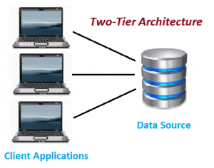
Figure 2.1.

The above diagram (Figure 2.1) shows the architecture of 2-tier. It shows the direct communication between client and server, and there is no intermediate between client and server, as mentioned earlier.

The 2-tier architecture is divided into 2 parts – Client Application (Client tier) and Database (Data tier).
On the client application side, the code is written for saving the data in the SQL server database. The client sends the request to server and it process the request and send back with data. Therefore, for example, when the guest wants to make a room reservation, then the receptionist will have to check the system by calling the room availability module then then the room availability module will reply by sending back a call with data on whether if there are rooms available at that particular time.

The benefits of 2-tier architecture are that it is easy to maintain and modification is a bit easy, as well as faster communication.

However, both tier architecture cannot respond multiple request at the same time, and as a result it cause data integrity issue. Also, it is cost-ineffective.

USER INTERFACE (UI) DESIGN

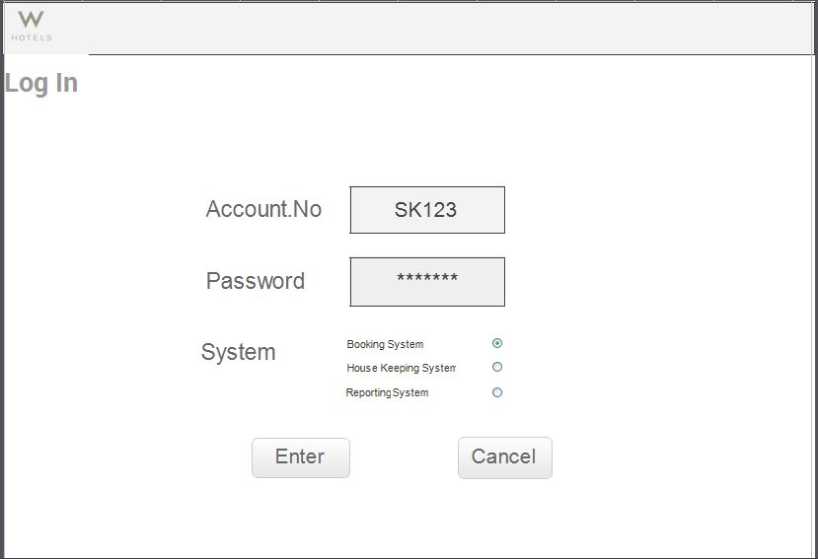
- Log In- will be the page where the first screen seems by user no matter the admin or the staff need to log in before using.

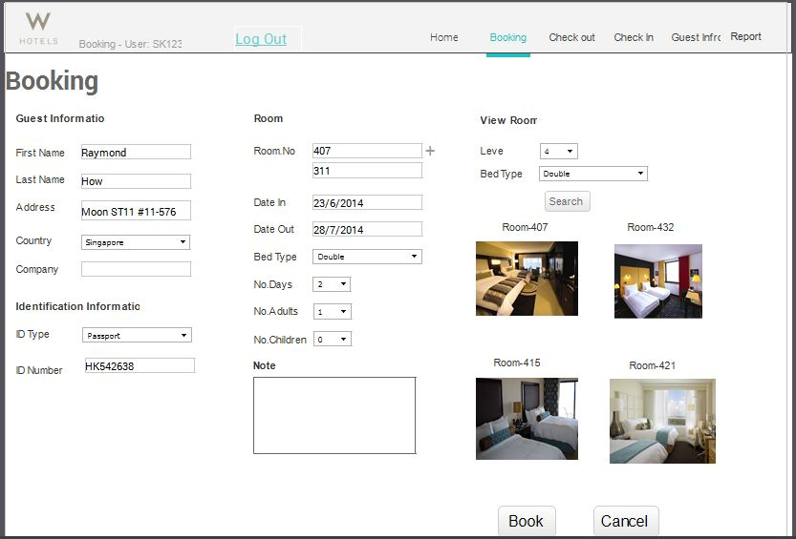

Booking- Guest able to view and select the room available, at the same time fill in personal detail.

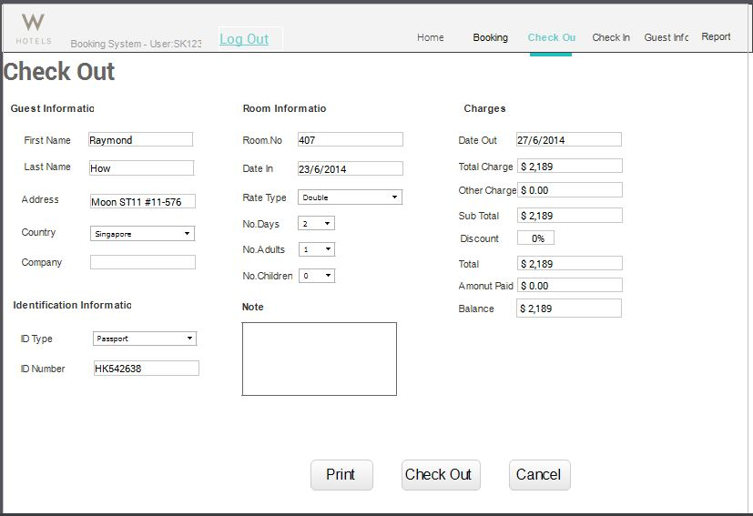

Checkout – This interface will be what staff will see wen check out for user. In this page total balance and charge will be listed to allow guest procced to payment.

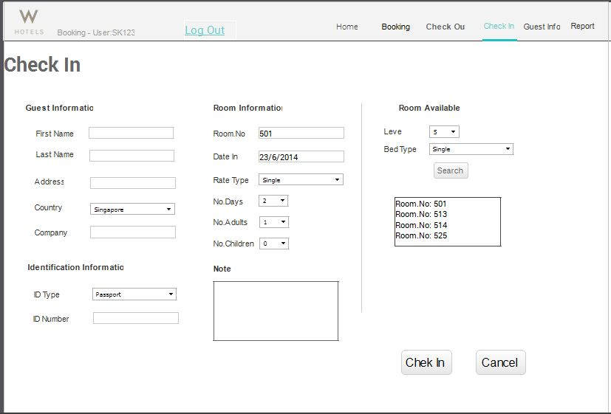

Check in – Allow the staff to key in all the person detail for the guest.

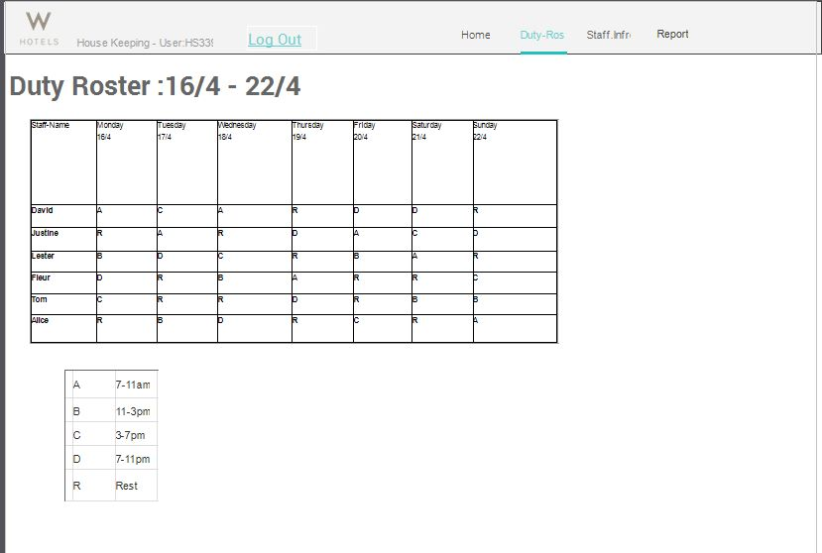

Duty Roster- show the people on duty and the slot of their job

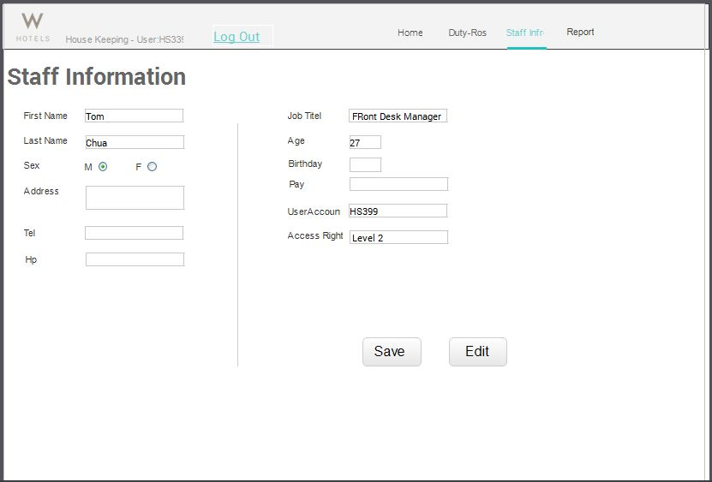

Staff info- this page allows the staff to view and edit the staff information

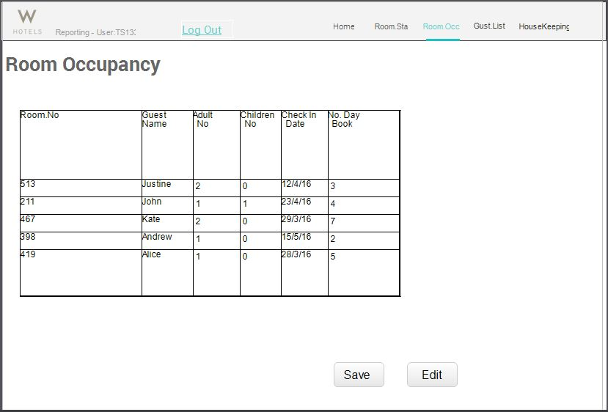

Room occupancy – this report allows the management t to view the guest who stay on the hotel.

PROGRAM DESIGN

Hotel Management System Use Case Diagram

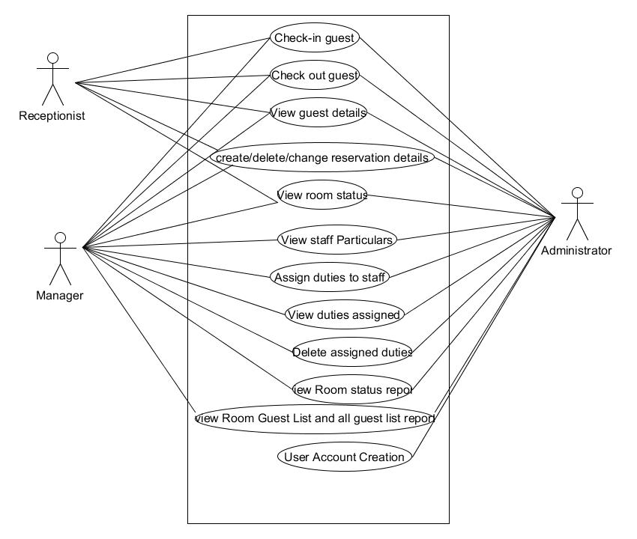

Basic Flow and Alternate Flows of all use cases

Use Case | Check-in guest
Actors | Receptionist
Description | Receptionist can check-in hotel guest
Pre-conditions | The receptionist has login to the system
Basic Flow | - The receptionist retrieve the booking information by  booking ID  - The receptionist assigned a vacant room to the guest  - The guest is successfully checked-in.
Alternate Flow  (Wrong check in date) | - The receptionist retrieve the booking information by  booking ID  - The receptionist assigned a vacant room to the guest  - The system display a message that the check in date has past.

Use Case | Check-out guest
Actors | Receptionist
Description | Receptionist can check-out hotel guest
Pre-conditions | The receptionist has login to the system
Basic Flow | - The receptionist retrieve the booking information by  booking ID  - The receptionist informs housekeeping staff to check on guest room  - The receptionist proceed to check out hotel guest
Alternate Flow  (Early check out) | - The receptionist retrieve the booking information by  booking ID  - The system informs the user that the checkout date is not today.

Use Case | View guest details
Actors | Receptionist
Description | Receptionist can view the personal particulars of the hotel guest
Pre-conditions | The receptionist has login to the system
Basic Flow | - The receptionist key in the guest ID on the system  - The system retrieves the guest particulars from the database.  - The system display the guest personal particulars of the guest.
Alternate Flow  (Invalid guest ID ) | - The receptionist key in the guest ID on the system  - The system informs the user that the guest ID is invalid.

Use Case | Create/Delete/Change reservation details
Actors | Receptionist
Description | Receptionist can Create/Delete/Change reservation details
Pre-conditions | The receptionist has login to the system
Basic Flow | - The receptionist key in the booking ID on the system  - The system retrieves the booking information from the database  - The system displays the booking details of a particular guest.  - The receptionist clicks on the edit button  - The receptionist proceed to modify the booking information
Alternate Flow  (No booking infomation) | - The receptionist key in the booking ID on the system  - The system retrieves the booking information from the database  - The system informs the user that the booking information is not found

Use Case | View room status
Actors | Receptionist
Description | The receptionist can view the room status of a particular room
Pre-conditions | The receptionist has login to the system
Basic Flow | - The receptionist clicks on the room over view page  - The receptionist clicks on room 063  - The system display the room status “occupied”
Alternate Flow  (Scheduled for cleaning ) | - The receptionist clicks on the room over view page  - The receptionist clicks on room 076  - The system display the room status “Room is scheduled for cleaning”

Use Case | View staff particular
Actors | Manager
Description | The manager can view the personal particulars of the staff
Pre-conditions | The manager has login to the system
Basic Flow | - The manager clicks on the housekeeping and staff management module  - The manager clicks on the staff list  - The system displays the names of all the hotel staff  - The manager clicks on a particular staff name  - The system display the staff particulars
Alternate Flow  (Database not accessible) | - The manager clicks on the housekeeping and staff management module  - The manager clicks on the staff list  - The system displays the names of all the hotel staff  - The manager clicks on a particular staff name  - The system informs the user that the database is not accessible

Use Case | Assign duties to staff
Actors | Manager
Description | The manager can assign housekeeping duties to the staff
Pre-conditions | The manager has login to the system
Basic Flow | - The manager clicks on the housekeeping and staff management module  - The manager clicks on the assign duties feature  - The manager selects a particular staff from the staff list drop down menu  - The manager selects a duty type from the duties drop-down menu  - The manager input some comments on the comments sections.  - The manager clicks on the assigned button
Alternate Flow  (Staff on leave) | - The manager clicks on the housekeeping and staff management module  - The manager clicks on the assign duties feature  - The manager selects a particular staff from the staff list drop down menu  - The system returns a message informing the user that the particular staff is on leave.

Use Case | View duties assigned
Actors | Manager
Description | The manager can view the housekeeping duties assigned to the staff
Pre-conditions | The manager has login to the system
Basic Flow | - The manager clicks on the housekeeping and staff management module  - The manager clicks on the assign duties feature  - The manager clicks on the view assigned duties  - The system returns a list of staff names with the duties assigned.
Alternate Flow  (Staff on leave) | - The manager clicks on the housekeeping and staff management module  - The manager clicks on the assign duties feature  - The manager clicks on the view assigned duties  - The system returns a message that there is no duties assigned yet.

Use Case | Delete assigned duties
Actors | Manager
Description | The manager can delete the duties that has been assigned to the staff
Pre-conditions | The manager has login to the system
Basic Flow | - The manager clicks on the housekeeping and staff management module  - The manager clicks on the assign duties feature  - The manager clicks on the view assigned duties  - The system returns a list of staff names with the duties assigned.  - The manager clicks on the edit button  - The manager proceed to delete the duties that he/she want to delete
Alternate Flow  (Duties cannot be deleted) | - The manager clicks on the housekeeping and staff management module  - The manager clicks on the assign duties feature  - The manager clicks on the view assigned duties  - The system returns a list of staff names with the duties assigned.  - The manager clicks on the edit button  - The manager proceeds to delete the duties that he/she want to delete  - The system informs the user (manager) that the selected duties cannot be deleted

Use Case | View room status report
Actors | Manager
Description | The manager can view the status report of all the room
Pre-conditions | The manager has login to the system
Basic Flow | - The manager clicks on the reporting module  - The manager selects the view room status report  - The system returns a list of rooms with their respective status.
Alternate Flow  (System error) | - The manager clicks on the reporting module  - The manager selects the view room status report  - The system encounter an error and return to the main page.

Use Case | View Room Guest List and all guest list report
Actors | Manager
Description | The manager can view the number of guest by room number and all guest list by date
Pre-conditions | The manager has login to the system
Basic Flow | - The manager clicks on the reporting module  - The manager selects the view room guest list reports  - The manager key in a particular room number  - The manager clicks on the ok button  - The system return the number of adults and children’s staying in that room
Alternate Flow  (Invalid room number) | - The manager clicks on the reporting module  - The manager selects the view room guest list reports  - The manager key in a particular room number (eg: 63)  - The manager clicks on the ok button  - The system informs the user that the room number is invalid. (should be 063)

Use Case | User Account Creation
Actors | Administrator
Description | The administrator can create new user account
Pre-conditions | The administrator has login to the system
Basic Flow | - The administrator clicks on the reporting module  - The administrator clicks on the user account management feature at the settings column of the reporting module  - The administrator selects the type of user account he/she want to create (normal user, management, administrator)  - The administrator key in a new user name  - The administrator key in 8-character password  - The administrator click on the create button
Alternate Flow  (Invalid room number) | - The administrator clicks on the reporting module  - The administrator clicks on the user account management feature at the settings column of the reporting module  - The administrator selects the type of user account he/she want to create (normal user, management, administrator)  - The administrator key in a new user name  - The administrator key in 8-character password  - The administrator clicks on the create button  - The system returns an error message informing the user that the user account capacity has exceeded. Please contact vendor

DATABASE DESIGN

There are some considerations made when designing the database such as the data type and the character limit. A hotel guest can be from any country, the name of the guest can be very long. As such, we set the character limit of the First Name and Last Name to 30 in the database. The phone number we set to 20 characters as some country phone number can be up to 15 digits. We set the character limitation of the remarks input to 500 and the data type to string as a remarks column should be able to accept any character. The hotel management system database need to store the customer details such as their name, address, email address and phone number as well as their country of residences and nationality. The database also need to store the credit card details of the customer.

LIMITATION

There is some limitation impose on the database design. For the country and nationality, the customer is not able to enter any other data other than a name of a country or a city. As for the credit card number, the guest should not be able to key in more than 16 digits.

CUSTOMER DETAILS

 | Data Type
GuestID (PK) | int
FirstName | varchar(30)
LastName | varchar(30)
PassportNo | Varchar
Gender | varchar
PhoneNumber | Int(15)
EmailAddress | varchar
Country | varchar
Nationality | varchar
StreetName | varchar
Block | Int
UnitNo | Int
PostalCode | int

BOOKING

 | Data Type
BookingID | Int (PK)
GuestID | Int (FK)
Bookingdate | Date
Checkindatetime | Datetime
Checkoutdate | Datetime
Noofadult | Int(4)
Noofchildren | Int(4)
NoOfDays | int

ROOM

 | Data Type
RoomID (PK) | Int
RoomType | Varchar
RoomDescription | Varchar
Smoking/NonSomking | Varchar
RoomStatus | Varchar
GuestID | int

BILL

 | Data Type
BillID | Int (PK)
BookingID | Int (FK)
GuestID | Int
RoomType | Varchar
BillingDate | Date
NoOfDays | Int
RoomCharges | Double
MiscCharges | Double
TotalCharges | Double

INVOICE

 | Data Type
InvoiceID (PK) | int
GuestID | int
BillID | int
RoomCharges | double
MiscCharges | double
TotalCharges | double
CREDIT CARD

 | Data Type
CardNumber | Int(16)
CardType | Varchar
CardHolderName | Varchar(60)
ExpirationDate | Date
CCV | Int(3)

STAFF

 | Data Type
StaffID | int
FirstName | varchar(30)
LastName | varchar(30)
DateOfBirth | date
Address | varchar(50)
PhoneNumber | int(8)
BankAccountNo | Int(9)

DUTIES

 | Data Type
DutiesID | int
DutiesType | varchar
StaffID | int
DutyStatus | varchar

Database ER Diagram

Room Management Module

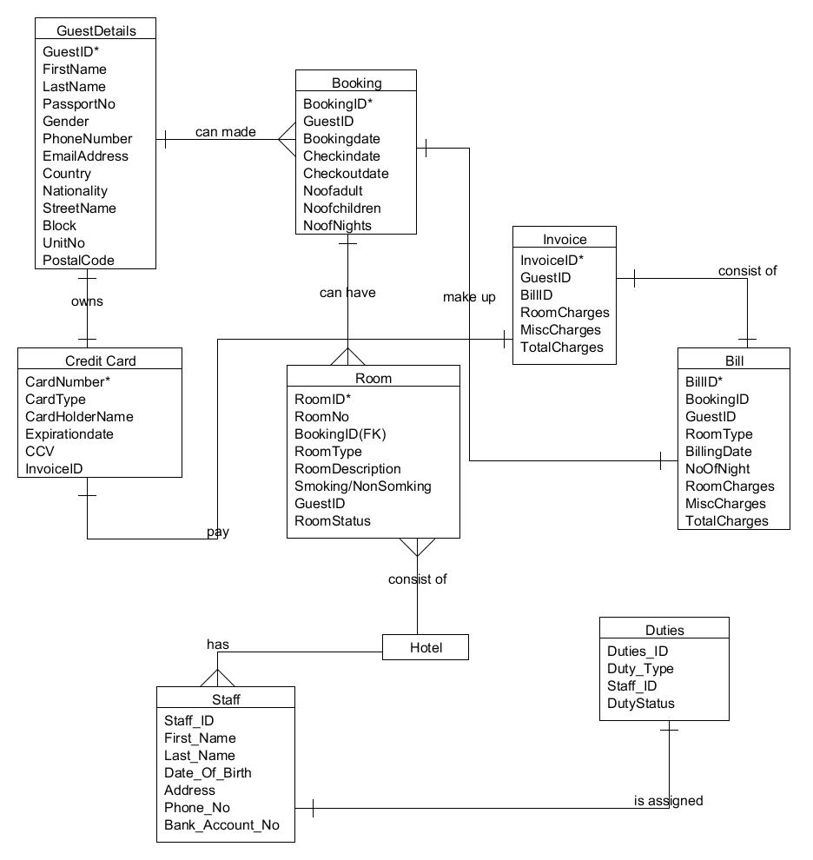

Database Schema

Room Management Module

GuestDetails (GuestID*, FirstName, LastName, PassportNo, Gender, PhoneNumber, EmailAddress, Country, Nationality, StreetName, Block, UnitNo, PostalCode)

Booking (BookingID*, GuestID, Bookingdate, Checkindate, Checkoutdate, Noofadult, Noofchildren, NoofNights)

Room (RoomID*, BookingID, RoomType, RoomDescription, Smoking/NonSomking, GuestID, RoomStatus)

Bill (BillID*, BookingID, GuestID, RoomType, BillingDate, NoOfNight, RoomCharges, MiscCharges, TotalCharges)

Invoice (InvoiceID*, GuestID, BillID, RoomCharges, MiscCharges, TotalCharges)

